Learning ggplot2 with Swirl

Aditya Dube

8. GGPlot2 Part1

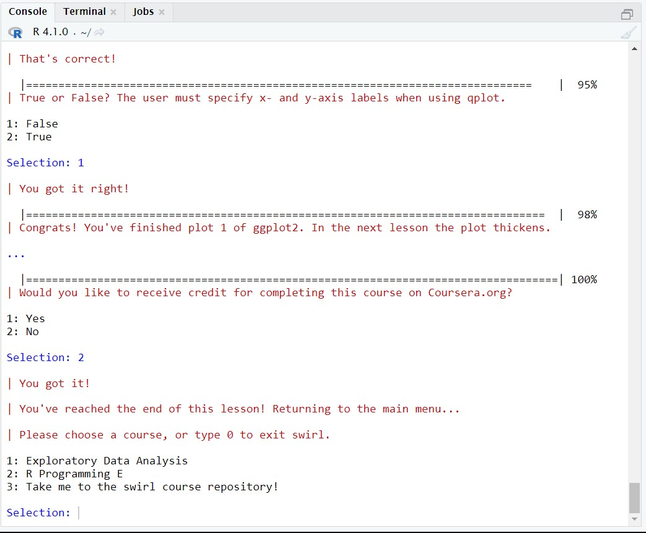

9. GGPlot2 Part2

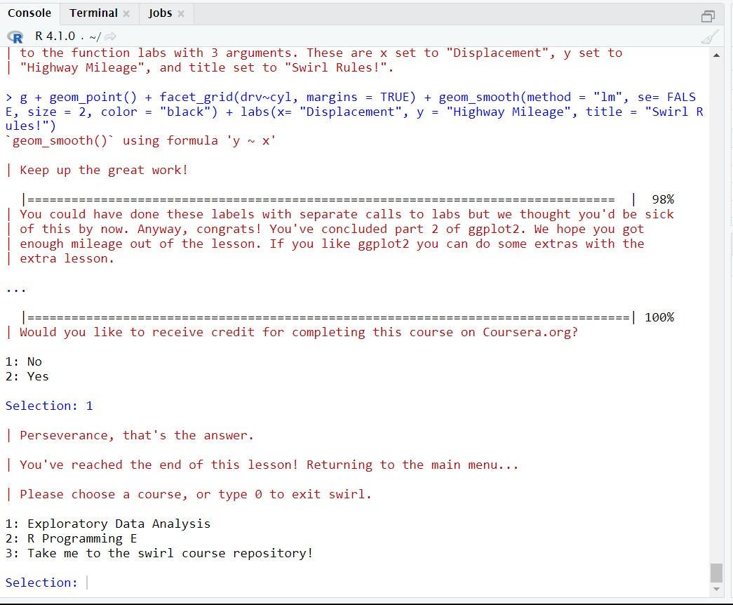

10. GGPlot2 Extras

